In this section, we will introduce the system design from several aspects, including use case design, class design and deployment design.

**4.1 Use Case Design**

Based on the requirement given by professor, we defined the use cases below. We identify all users whether he is or not an author to be a user.

The use case diagram we designed is shown in picture 4-1.

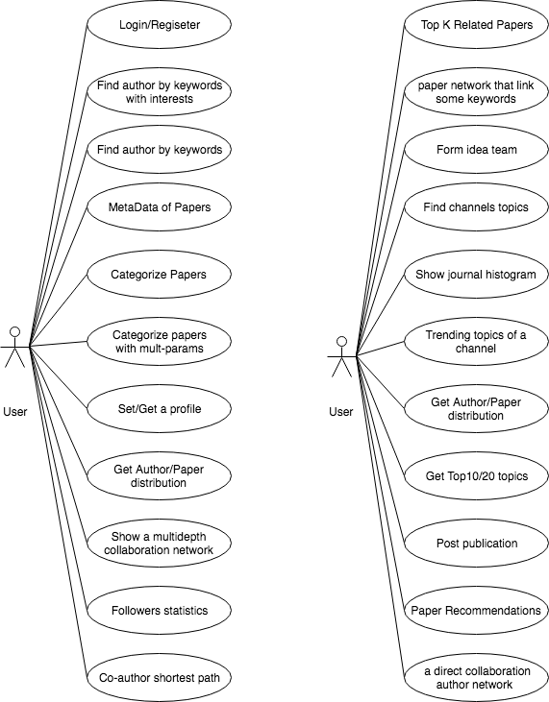

Fg. 4-1 Use Case Diagram

**4.2 Class Design**

Based on the use cases we identified above, we defined 4 classes entities to satisfy the requirement. The 4 classes including Author, Keyword, Searchedkey, Paper. Each class is corresponding with at least one use case.

The class diagram is shown in below picture 4-2:

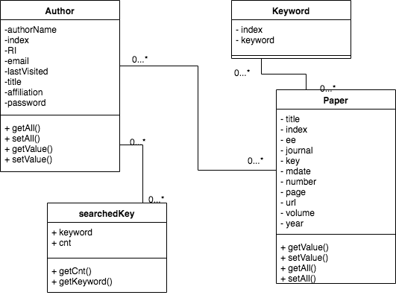

Fg. 4-2 Class Diagram

**4.3 Structure Design**

The structure of the whole system and the deployment view is shown in below picture 4-4:

In the client side, it contains frontend page logic controls, including page view and page logic. In the Server side, it contains backend business logic controls, including controller and repository, they are used to response the request from frontend and provide specific service.

FrontEnd/Client BackEnd/Server

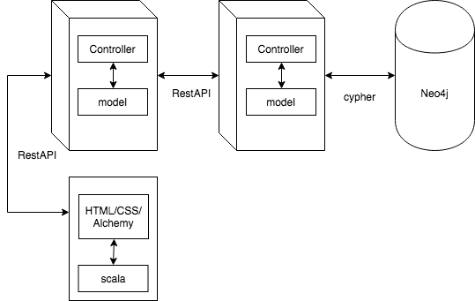

Fg. 4-3 Deployment View

We use play framework to deal with both the frontend and the backend. Meanwhile, we use scala and Alchemy.js for viewing. Also, we use Neo4j and cypher to operate the database, it’s allowed us to binding the data from Neo4j and model.